FOR IMMEDIATE RELEASE

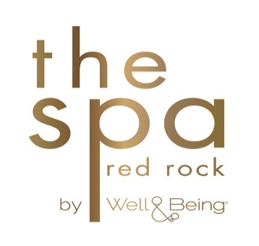
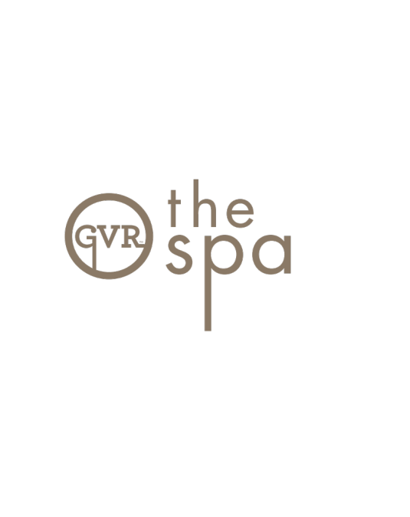

THE SPA AT RED ROCK BY WELL & BEING AND THE SPA AT
GREEN VALLEY RANCH RESORT ROLL OUT ALL-NEW
SPA MEMBERSHIP PROGRAMMING

LAS VEGAS (May 18, 2017) – The Spas at Green Valley Ranch Resort and Red Rock Resort are making a splash this season with its all-new spa and fitness monthly membership program. Transforming spa and fitness offerings into a monthly must-have, both properties now offer local residents unique monthly memberships at the choice of The Spa at Red Rock by Well & Being or The Spa at Green Valley Ranch Resort – all for a one-stop-shop spa escape.

Spa and fitness enthusiasts seeking bliss, serenity and restoration in a true resort setting, can now indulge in this special monthly membership program, available at $200 per person per month. The Spa at Red Rock by Well & Being and The Spa at Green Valley Ranch Resort provide the benefits of membership with the extravagance of a luxury environment.

This exclusive monthly membership features the following:

- Preferred pricing on signature massage and facial services
- Unlimited group fitness exercise classes (more than a dozen class are offered weekly including boot camp, yoga and Pilates, along with one-of-a-kind offerings such as wall yoga, violin guided meditation and more)
- Unlimited access to the spa pool, spa locker areas, fitness center
- Use of men's or women's jacuzzi, steam and sauna
- 10% off spa products
- Two complimentary day passes for member’s guests, each month
- Additional monthly perks such as spa credits, spa products and more
- Complimentary monthly bod pod/body composition measurement session (available for The Spa at Red Rock by Well & Being members only)

Located in Henderson, The Spa at Green Valley Ranch encompasses over 40,000 square feet of lavish space with a private lap pool, a full-service salon and a top-of-the-line fitness studio. The award-winning spa offers an array of services including massage and body treatments, facials, waxing and nail services for a complete oasis. The Spa at Green Valley Resort and Casino is open daily from 6 a.m. to 8 p.m.

The Spa at Red Rock by Well & Being is located in Summerlin and offers a variety of personalized experiences designed to transform guests from the inside out with its unique nutrition and exercise programs. Guests are encouraged to participate in the multitude of services offered from the open-air pool to wall yoga and much more. The Spa at Red Rock by Well & Being is open daily from 6 a.m. to 8 p.m.

Membership will be exclusive to the location purchased and are available for purchase month-to-month. For a full list of class schedules, visit The Spa at Red Rock by Well & Being or The Spa at Green Valley Ranch Resort. For more information about the all-new monthly membership programming, visit greenvalleyranch.sclv.com/ and redrock.sclv.com/.

###

About Green Valley Ranch Resort:
The AAA Four Diamond award-winning Green Valley Ranch Resort offers an array of luxury amenities and an elevated level of service for locals and tourists alike. Green Valley Ranch Resort boasts nearly 500 guest rooms and suites; an award-winning 30,000-square-foot spa; an 8-acre backyard pool area; a Regal Cinemas movie theater; a variety of restaurants including the award-winning Hank’s Fine Steaks & Martinis and Pizza Rock by 11-time world pizza champion Tony Gemignani as well as a full array of gaming offerings including a race and sports book, poker room, slot and video poker machines, table games and a bingo room. The resort is located at 2300 Paseo Verde Pkwy., Henderson, Nev. 89052. To learn more about Green Valley Ranch Resort, please call 702.617.7777 or visit https://greenvalleyranch.sclv.com/.

About Red Rock Resort
Located 10 miles west of the Strip, Red Rock Resort is a four diamond AAA-rated resort that features more than 800 guest rooms and suites, a 25,000-square-foot spa, a variety of restaurants, a spectacular pool area, movie theatres, bowling at Red Rock Lanes and a full array of gaming. To learn more about Red Rock Resort, please call 702-797-7777 or visit https://redrock.sclv.com/.

Media Contacts:
Lori Nelson
Station Casinos
lori.nelson@stationcasinos.com
702-495-4248

Sara Ryan / Ella Mokamba
Allied Integrated Marketing
stationcasinos@alliedim.com
702-889-2705

